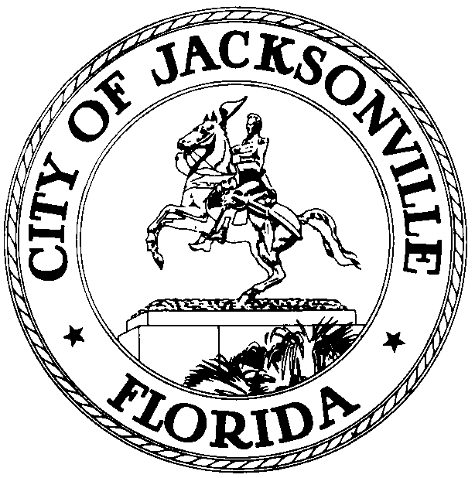

OFFICE OF THE CITY COUNCIL

Jacksonville Waterways Commission (JWC)
117 W. Duval Street, Suite 425, Jacksonville, Florida 32202

NOTICE

TO: Jacksonville Waterways Commission’s
River Accord Task Force

Commissioner Jon Michael Barker
Commissioner Richard Hartley
Commissioner Richard J. Redick
Commissioner Adam Hoyles
St. Johns Riverkeeper Lisa Rinaman

FROM: Council Member Jimmy Peluso, Chair

RE: 20240419 Notice JWC’s River Accord Task Force Meeting

Notice is hereby given that the JWC’s River Accord Task Force will meet on Friday, April 19, 2024, at 10:00 a.m. in the Lynwood Roberts Room, located on the 1st floor, City Hall - St. James Building, 117 W. Duval Street, Jacksonville, FL 32202. The purpose of this meeting will be to discuss the accomplishments of the objectives from the 2006-2016 MOU and discuss outstanding opportunities.

All interested parties are invited to attend.

For general meeting information or questions please contact the Legislative Services Division at (904) 255-5122.

ADA Accommodation Notice:
Pursuant to the American with Disabilities Act, accommodations for persons with disabilities are available upon request. Please allow 1-2 business days' notification to process; last-minute requests will be accepted but may not be possible to fulfill. Please contact Disabled Services Division at: V (904) 255-5466, TTY (904) 255-5476, or email your request to KaraT@coj.net.

Noticed on: April 12, 2024, at 12:00 p.m. pursuant to 15.103 (c), Ordinance Code.

JP/vg

cc: Council Members and Staff
Margaret “Peggy” Sidman, Director/Council Secretary
Merriane Lahmeur, Chief, Legislative Services Division
Yvonne Mitchell, Chief, Administrative Services Division
Jeff Clements, Chief, Research Division
Teresa Eichner, Chief, Public Information
CITYC@COJ.NET
Electronic Notice Kiosk – 1st Floor City Hall
Public Notice System – City Council Web Page
Media Box
File Copy

